The History of Women in Rodeo

By: Mackenzie Heumiller

NCGP

Zimmerman Fall 2015

The History of Women in Rodeo
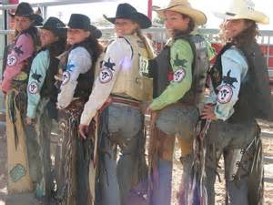
Women's rodeo goes back many centuries. “Between 1890 and 1942 over 450 women had professional rodeo careers” (Wood). As of today there is bound to be more. For a long time men have dominated the world of rodeo but they failed to see how tough women can be. Women fought for what they wanted and got it! The industry of women’s rodeo has grown tremendously over the years. It has evolved into a professional sport especially for women.
People started rodeoing in hopes of being able to make some money. “Rodeos origins involved matchups between bad bucking horses and bronc riders and ropers off of ranches which lead to standard events and people followed the rodeo trail as a means to making money” (Wood). While this was mainly a profession of men, women were hired as mounted pistol shooters, trick riders, and stunt riders. “In 1885, Annie Oakley was hired by Buffalo Bill Cody as a sharpshooter in his Wild West show, but later helped create the iconic image of the cowgirl when she appeared in a western film shot by Thomas Alva Edison in 1894” (Women). A few years later in 1903 women began competing at the Cheyenne Frontier Days. Even though there weren’t a large amount of female professional riders, rodeo promoters would advertise female riders as sweethearts or queens of the rodeo. By 1920 women actually competed in rodeos as relay racers, trick riders, and roughstock riders.
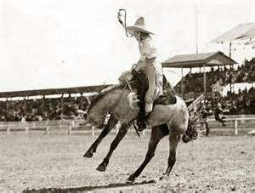
Women weren’t accepted because of the fear everyone had that they would get hurt competing alongside the men. Because of this fear the Cheyenne Frontier Days ended their women’s roughstock riding events. Then in 1929, bronc rider Bonnie McCarroll died at the Pendleton Round-Up. She was thrown from a horse and got her foot stuck in the stirrup causing her to be drug around the arena (Women). This accident proved everyone right and made women even more unaccepted in the rodeo arena. “When the Rodeo Association of America (RAA) was formed in 1929 under the direction of Gene Autry, no women’s events were included” (Women). This along with the Great Depression caused rodeo to be set on the back burner for most women and made it hard for them to find work. In 1931, when rodeo sponsor contests were born, women saw a chance to get back on their feet. They decided the contests would focus on femininity rather than athleticism. Finally, rodeo women made a comeback as graceful promotional figures rather than athletes.
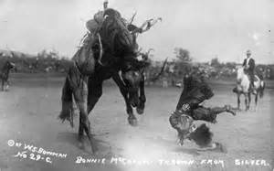
Women began to see a change in rodeo specifically for them. “The Girls Rodeo Association was formed in 1948 after a rules dispute at an event” (Casey). Amazingly women started hosting their own rodeos all over the United States. Barrel racing was made the main event where they would pair the fastest horses with the most skillful riders to race against the clock. “The Girls Rodeo Association crafted rules and guidelines for nearly 10 women only events” (Casey). In order to create equality between the men and women of rodeo the women only events closely mimicked those of men’s rodeos. The Girls Rodeo Association then made its transition into the Women’s Professional Rodeo Association or the WPRA.
The WPRA World Finals is the largest women’s only rodeo in the entire world. Women compete in original WPRA events such as barrel racing, bull riding, bareback riding, tie-down roping, breakaway roping, and team roping (Casey). Roughstock riders earned points by being scored based on their skill and technique. To keep the fairness, in both timed and roughstock events the rules are similar to the rules in male-dominated competition. “Each event champion wins a saddle specifically designed for that event” (Casey). As a competitor you can expect to have very little down time. The rodeo seasons fall fairly close to one another. So as soon as one season ends the training for the next season begins. If you truly have the passion for the sport it is all worth it.
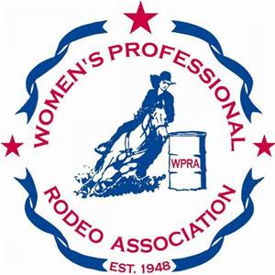
Some of the greatest women in history were rodeo competitors. “Mabel Strickland started her career as a trick rider at the Walla Walla Frontier Days in Washington” (Jones). She competed in saddle bronc riding, steer roping, and relay racing as well. Strickland was a tough cowgirl who competed against both cowboys and cowgirls along with setting not only one but several world records (Jones). She was also known for her acting in movies and doing amazing stunt work. “Wanda Harper Bush is one of the most decorated women in rodeo’ (Jones). By the end of her competing days in 1985 she had won 29 barrel racing championships and 33 world championships including three all-around titles. When she stopped competing she started training horses for a living and today she is known for her skills with horses and training clinics.
Women’s professional rodeo continues to live on and those who paved the path to freedom and equality will always be remembered and respected in the rodeo community. Ann Secrest Hanson is one who is respected by the cowboys. She helped them off their broncs working as a pickup “man”, from high school to PRCA level (Wood). It is women like Ann Secrest Hanson, Annie Oakley, Wanda Harper Bush, and Fay Kirkwood (who staged the all girl rodeo as a protest against the male dominated rodeos) that have shaped women’s rodeo into what it is today. “Women are a strong force in rodeo, whether in the WPRA or the regional associations” (Wood). Although few women ride roughstock today, there are still some with the guts to give it a try. Because of the drive, tenacity, and fight these women have in and out of the arena, women are in rodeo for good.
Almost 15 years ago, Susan Swain worked at a trailer dealership that wanted her to expand her knowledge to help her better sell the trailers. So they bought her a nice horse and trailer and sent her on the road. Susan now feels that women who compete in rodeo events such as barrel racing stay out of trouble, and she believes that it is a healthy sport mentally and physically. She describes professional rodeo has a healthy environment but is only for certain people. In order to compete in rodeo at a professional level Susan says you definitely need family support mentally and financially, and the drive to make it a career. Susan thinks that in order to make competing in rodeo a career, you have to live in a place that allows you to travel to all the rodeos and have the money to do so.
The growth of women’s rodeo over the years is indescribable. The sport has evolved into a profession for many, especially women. “The WPRA world finals is the largest women’s only rodeo in the entire world” (Casey). Women have paved the way for rodeo today. The acceptance of women in the rodeo world seems to be just short of a miracle. Knowing though that women did not need a miracle, they just needed each others back bone. From now on women's professional rodeo will host women’s only events such as barrel racing. Women can look forward to seeing their favorite rodeo cowgirls in the NFR (National Finals Rodeo) and the WPRA world finals for years to come.
Works Cited
Casey, Stevee. "Women in Rodeo." About. N.p., n.d. Web. 28 Sept. 2015. <http://rodeo.about.com/od/rodeoevents/a/Women-In-Rodeo.htm>.
Jones, Autumn. "The Greatest Women in Rodeo." American Cowboy. N.p., 2015. Web. 28 Sept. 2015. <http://www.americancowboy.com/article/greatest-women-rodeo-24584>.
Toy, Chelsea. "History of the Rodeo Cowgirl." American Cowboy. N.p., 2015. Web. 28 Sept. 2015. <http://www.americancowboy.com/article/history-rodeo-cowgirl>.
"Women in Rodeo." Wikipedia. N.p., 20 July 2015. Web. 28 Sept. 2015. <https://en.wikipedia.org/wiki/Women_in_rodeo>.
Wood, Jan Swan. "HERE TO STAY: History of the Women Who Compete in Rodeo." Tri-State Livestock News. N.p., 6 May 2015. Web. 28 Sept. 2015. <http://www.tsln.com/news/16224602-113/story.html>.

